LORDGRACE DELIGHT HEALTHCARE LIMITED

Location Assessment & Local Profile

THE POFILE
Oval Gardens in is in the Eastern region of England located in Little Thurrock Rectory, Grays. It comprises of two units within the same compound that comprise of 6 bedroom house and semi-independent flat. Its quiet a distance from Grays centre which is idea for the provision of support for the young people.
KEY DUTIES

MANAGEMENT TEAM
Management team must familiarise themselves with the risk register documentation and ensure they understand the risk process and how risk registers are used to identify, record and address risks.
They must use risk assessment to proactively manage risks within their area of responsibility and ensure that suitable controls are implemented that are proportionate to the level of risk.
Ensure significant risks identified are escalated immediately if a control measure is not possible or the required actions are outside of their remit of responsibility.
Managers must also formally review the information contained in the risk register at local, at least a quarterly basis, or after changes to the workplace, activities or following consideration of information provided, for example analysis of incident reports.
Any consideration of new risks or changes to the risk register must be recorded using the risk assessment form.
Managers must involve staff in the review and completion of risk assessments and the risk register and ensure that employees are aware of the process and content of the risk register. It is recommended that the risk register and risk assessments are on the agenda for discussion and review at team meetings.

SERVICE MANAGER
Has responsibility for compiling and maintaining the Risk Register.
Will maintain the risk register module providing regular reports to the services on the content and status of risk assessments and risk registers trust wide.
Will provide training and support to staff on the compilation and use of risk assessments and risk registers.
Have responsibility and accountability for ensuring through service management meetings the services are reviewing risk register documentation monthly to ensure it remains effective.

ALL EMPLOYEES
Have responsibility for ensuring they understand the process of and findings of risk assessments and follow the controls and identified actions outlined in the risk register and risk assessments. They also have a responsibility to make managers aware of any risks to service users’ safety, health and safety or other risk issues
Risk Assessment and Risk Management Strategies

1.PEN PICTURE OF THE IMMEDIATE LOCALITY:
Lordgrace Delight HealthCare Limited is committed to maintaining the health, safety and well-being of its employees, visitors, and the young adult in its care. The organisation recognises that suitable risk assessment is an essential tool in helping to identify and manage significant risks associated with a diverse range of activities and operations.

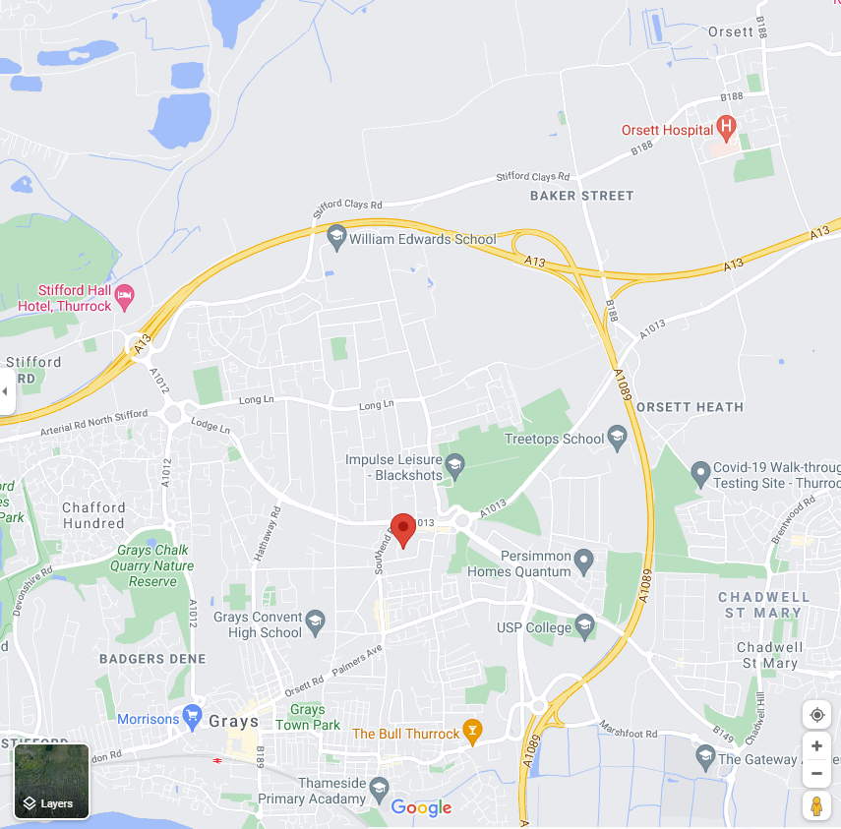

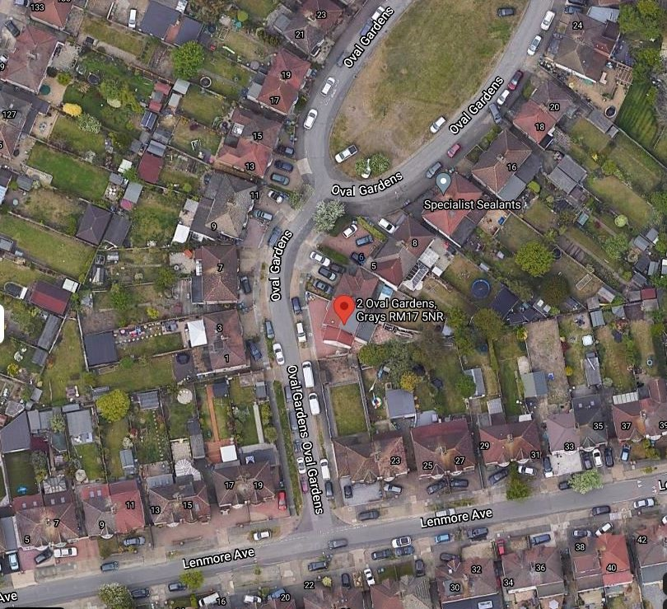

The nearest police station is Brooke Road, Grays, RM17 5BX. Access to Hospital is via Thurrock Hospital which is approximately 4 miles.
Oval Gardens leads to Lenmore Avenue Road which has a high level of vehicle traffic. The local are predominantly residential with easy access to local bus stops.

Local travel amenities are available within 600 yards with bus routes allowing travel to and from Romford central and central London

3. RELATIONSHIPS WITH THE LOCAL COMMUNITY
We have good links with the charity that support children with profound learning and physical disabilities to provide specialist equipment, play and craft materials and entertainment. The charity has supported our children’s Christmas party, has supplied upgraded television equipment for the children and young people’s bedrooms as well as numerous outings.
Cultural mix
Residents in Oval garden area come from diverse communities with the following ethnic group;
5% Black
6% Asian
87% White British
2% Mixed
0% others

The local area benefits from a healthy mix of cultures and does not consist of a significant one - sided majority of ethnicities.
Places of interest We have good links with the charity that support children with profound learning and physical disabilities to provide specialist equipment, play and craft materials and entertainment. The charity has supported our children’s Christmas party, has supplied upgraded television equipment for the children and young people’s bedrooms as well as numerous outings.

REVIEW OF CURRENT CRIME, DEPRIVATION AND LOCAL HEALTH ISSUES
Safer Neighbourhoods Team (SNT) is a group of Met police officers dedicated to serving the community. The team is made up of officers based in the area supported by additional officers from the wider area.
They work closely with local authorities, community leaders and residents to decide our policing priorities for the area. This helps us to find useful, long-term solutions to local problems, while maintaining our wider focus on reducing crime across London.
The Safer Neighbourhood Team address local community issues to which police are capable of providing a response without the need for long-term activity or requiring little if any partnership working. For example, dealing with minor disorder caused by youths congregating.

SAFEGUARDING CONCERNS AND ASSESSMENT CONCLUSION
There are no major concerns about the locality in which the home is based. There are low levels of crime, and the area is not highlighted by the local neighbourhood team or the LASS group as an area of concern.
There are minimal concerns of young people being drawn into gang crime or anti-social behaviour in the area. The home’s location does not increase the potential for children to be targeted for sexual exploitation, there are a number of take-aways and shops locally but still a distance from the immediate area.
There are hot spots for exploitation of young people but this has declined over the past 2 years based on incident and police reports, however, the central and main area of Grays approximately 1.5 miles away has had its fair share of criminal /antisocial incidents including some prostitution and drug trafficking in the darker lit side streets. This is on a steady decline though.
The home is situated in a quiet leafy road of family homes with large extensive gardens. The street itself has nil to little criminal activity and is quite a pleasant area with good neighbours near to an educational facility.
The road does not pose a high risk as the young people are of an age where they can cross the road safely and they do not need to cross the dual carriageway to access local shops etc.
The overall risk of the location of the home is assessed as being medium to low risk and it is in a neighbourhood watch area.
In case of safeguarding concern or abuse the initial point of contact is the Thurrock Multi Agency Safeguarding Hub (MASH) – Tel - 01375 652 802 – email – thurrockmash@thurrock.gov.uk Emergency out of hours – 01375 372 468 (4:30pm to 9am during the week and all throughout the weekend) Police Child Abuse Team – 01277 266 822.
CHILDREN WHO GO MISSING
If an agency becomes aware of a child who is missing, they should contact the Thurrock Multi-Agency Safeguarding Hub (MASH) – 01375 652 802 – email - thurrockmash@thurrock.gov.uk Emergency out of hours – 01375 372 468
CHILD SEXUAL AND CRIMINAL EXPLOITATION
If a child placed in Thurrock by another local authority is discussed at this group we would expect that the allocated social worker attends this meeting. Full details of known risks for children placed in Thurrock should be identified prior to placement and updated where new risks are identified at any time during the placement. If you have a looked after child and have concerns please contact the Thurrock Multi-Agency Safeguarding Hub (MASH) – 01375 652 802 – email - thurrockmash@thurrock.gov.uk Emergency out of hours – 01375 372 468
YOUTH OFFENDING SERVICES
Thurrock has a Youth Offending Team based in Corringham. They can be contacted on 01375 652 90. Email – grp.thurrockyot@thurrock.cjsm.net

Crime Breakdown September 20 – August 21

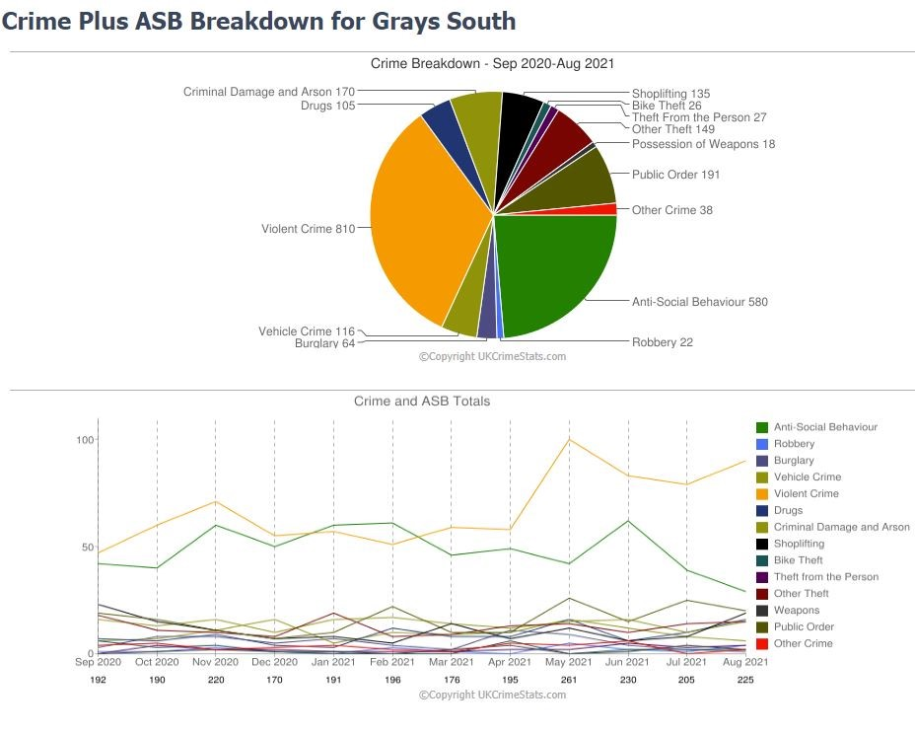
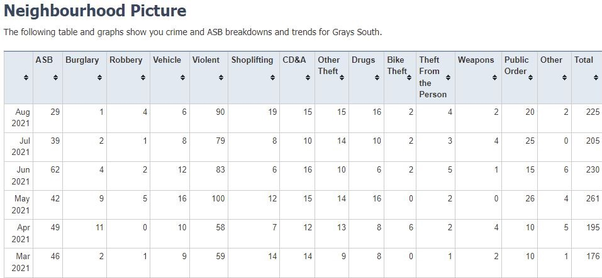
Thurrock, the parent community of Grays is located on the north side of the River Thames, immediately to the east of London.

OPPORTUNITY AND GROWTH
We are home to some of the most exciting opportunities in the country. Our growth programme is possibly the largest and most ambitious in the country.
£6 billion has already been invested by the private sector in Thurrock up to 2017, with 7,000 new jobs created and 1,170 new businesses coming to the borough, including leading ports and logistics centres, retail and creative industries.
We expect a further 30,000 new jobs to be created by the year 2037. More than 1,000 acres of land are ready for commercial development, with 30,000 new homes likely to be built.
Thurrock is at the heart of global trade and logistics, with no fewer than 3 international ports. We are well positioned on the M25 and A13 corridors, with excellent transport links west into London, north and east into Essex, and south into Kent.

CULTURE AND COUNTRYSIDE
Thurrock has a unique cultural identity that includes 2 historic forts and many areas of wildlife and natural beauty.
Our larger towns are Corringham, Grays, Purfleet, Stanford-le-Hope and Tilbury, yet Thurrock is 70% greenbelt with rural villages such as Bulphan, Orsett and Horndon on the Hill.

OUR COMMUNITIES
We have a growing community that brings increased demand for public services.
Our total numbers of residents of different ages are similar to regional and national figures. Overall, however, we have a higher proportion of children aged up to 4 years-old, and adults between 30 and 44 years-old. We have a smaller proportion of people aged 65 years and older.
Our population has become more ethnically diverse over the last 10 years. Ages and ethnicities vary a lot between our 20 wards.

CHILDREN AND YOUNG PEOPLE
Thurrock has a young population compared with the rest of England.
7.7% of the population is 0 to 4 years-old, whilst 27.1% is 0 to 19 years-old. The number of 0 to 19 year-olds in Thurrock is expected to pass 50,500 by 2037, and may increase further as a result of the local economic growth. The proportion of children under 15 years-old is highest in Tilbury, Chafford, North Stafford, West Thurrock and parts of Ockendon.

ETHNICITY
Our young population is becoming more diverse. Latest data from 2012 shows 26.5% of Thurrock school-aged children are from a black and minority ethnic group, compared with 19.1% of our total population. Thurrock has a slightly higher proportion (0.3%) of Gypsy, Roma and traveller children compared with the national population (0.2%).
DEPRIVATION
Overall levels of deprivation in Thurrock are lower than the national average, but some areas of Thurrock are among the 20% most deprived in England.
More than 1 in 5 children under 16 years-old in Thurrock are growing up in poverty (21.2%), higher than the national rate (20.1%). Child poverty is more concentrated in the most deprived areas of Thurrock – 6% of children live in poverty in parts of Grays Thurrock and Little Thurrock Rectory, whereas the figure rises to 56.4%.in parts of Tilbury.

Official statistics

TRANSPORTATION

55 / Average

DAILY LIFE

85 / Good

SAFETY

80 / Average

HEALTH

90 / Good

SPORTS AND LEISURE

80 / Good

ENTERTAINMENT

88 / Good

DEMOGRAPHICS

90 / Good

